Atoms:

1. Button
2. Radio Button



1. Label



1. Title



1. Stats



1. Circle Container



1. Rect Container



1. Notes



Molecules:

1. RadioButtonGroup
2. Display Stats

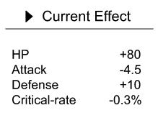

1. EmblemsContainer

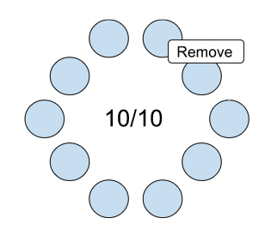

1. PokemonsContainer

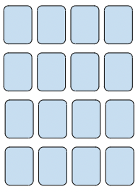

Organism:

1. FilterForms
2. DisplayEmblemsEffect



1. DisplayPokemonStats

